


AWS Agent Setup
Objective:
The Data Productivity Cloud Agent is an integral part of the Data Productivity Cloud framework. It functions as a connector between the user's data environment and the centralized platform, facilitating the execution and scheduling of compatible pipelines.

Prerequisites
- Access to AWS, with the permissions to create a stack on a billable account. You may need an administrator from your organization to either give access or perform this process with you.
- Permission’s to provision cloud resources in the AWS environment that the source database is running in.
- An IAM role that has suitable permissions for Data Productivity Cloud. If you're using the same IAM role, you might need to add cloudformation.amazonaws.com to the Service section in the Trust Relationship section of your IAM role to allow the role to work with the ECS service.
- An example trusted entity can be found below:
{
"Version": "2012-10-17",
"Statement": [
{
"Sid": "",
"Effect": "Allow",
"Principal": {
"Service": "cloudformation.amazonaws.com"
},
"Action": "sts:AssumeRole"
}
]
}

Created resources

This template will create the following resources in your AWS account:

ECS task definition.

ECS Fargate cluster.

CloudWatch Log group.

An entry in AWS Secrets Manager.

IAM Roles with permissions for the following:

Task Roles to your ECS, EC2, and Secrets Manager.

Task Execution Roles to pull from ECR Public repositories.

Visualization
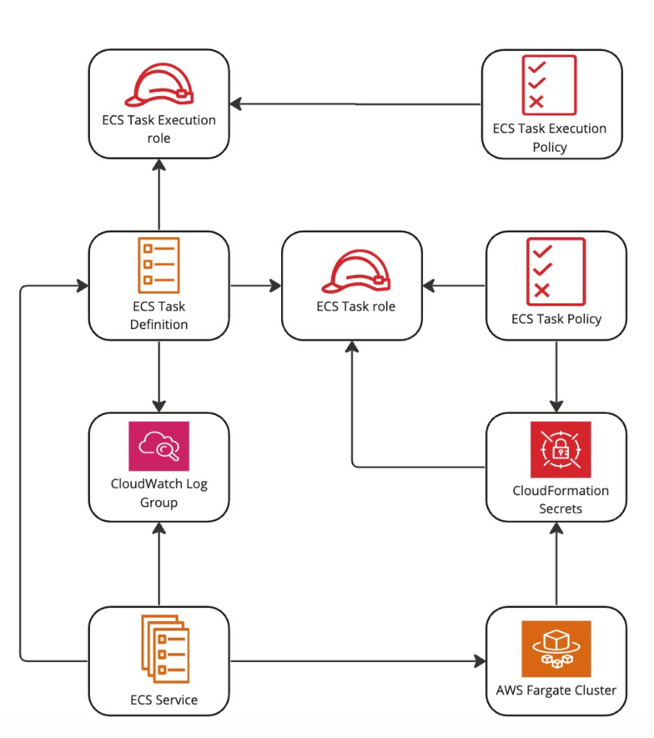
- Using the CloudFormation link

Create an agent in Data Productivity Cloud.

On the Agent details page, note the Credentials:client_id and client secret.

At the bottom of the page, click the Run in CloudFormation button. This will launch the CloudFormation stack in the AWS Console with pre-filled values for most parameters.

Complete the remaining parameters as follows:
    - Stack Name: An arbitrary name given to the created stack. Must be unique. This will be pre-filled, but if you are reinstalling an agent you will need to change the stack name. Consider increasing the number that is added to the end of the stack name.
    - OAuth Client ID: Copy the retrieved client_id from the Agent Details page.
    - OAuth Client Secret: Copy the retrieved client_secret from the Agent Details page.
    - VPC Id: Select the ID of an existing VPC. For more information, read VPCs.
    - VPC Subnet Ids: Select at least one VPC Subnet to use.
e. Click Create stack.

Once your stack is ready, this means the ECS service has now successfully deployed. The agent will then start. You can return to the agent dashboard and view the agent’s list. Your new agent will be on the list and will have a Running status.

Following details on the Custom Deployment page:

Client ID | Enter the client_id credential obtained from the Agent details screen.
Client Secret | Enter the client_secret credential obtained from the Agent details screen.

AWS IAM Privileges
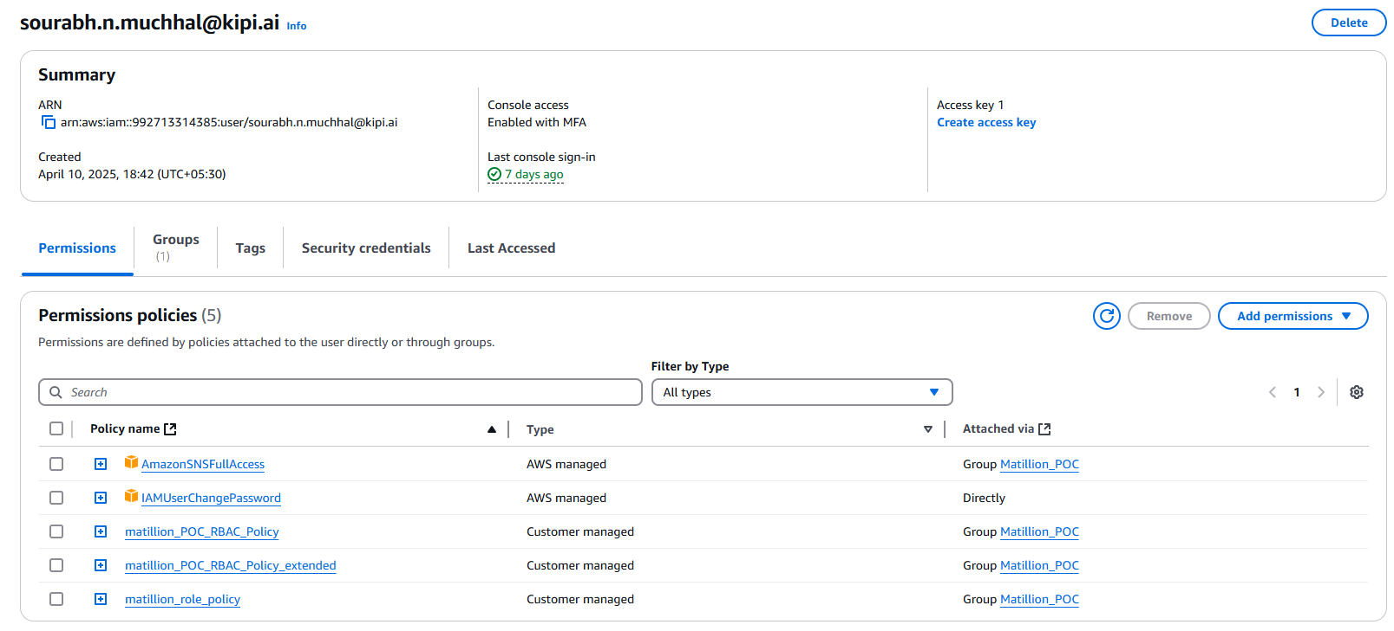
IAM as follows:
1. AmazonSNSFullAccess:
{
"Version": "2012-10-17",
"Statement": [
{
"Sid": "SNSFullAccess",
"Effect": "Allow",
"Action": "sns:*",
"Resource": "*"
},
{
"Sid": "SMSAccessViaSNS",
"Effect": "Allow",
"Action": [
"sms-voice:DescribeVerifiedDestinationNumbers",
"sms-voice:CreateVerifiedDestinationNumber",
"sms-voice:SendDestinationNumberVerificationCode",
"sms-voice:SendTextMessage",
"sms-voice:DeleteVerifiedDestinationNumber",
"sms-voice:VerifyDestinationNumber",
"sms-voice:DescribeAccountAttributes",
"sms-voice:DescribeSpendLimits",
"sms-voice:DescribePhoneNumbers",
"sms-voice:SetTextMessageSpendLimitOverride",
"sms-voice:DescribeOptedOutNumbers",
"sms-voice:DeleteOptedOutNumber"
],
"Resource": "*",
"Condition": {
"StringEquals": {
"aws:CalledViaLast": "sns.amazonaws.com"
}
}
}
]
}


2. matillion_POC_RBAC_Policy

{
"Version": "2012-10-17",
"Statement": [
{
"Sid": "VisualEditor0",
"Effect": "Allow",
"Action": [
"iam:GetPolicyVersion",
"iam:GetAccountPasswordPolicy",
"iam:ListRoleTags",
"iam:GetMFADevice",
"iam:ListServerCertificates",
"logs:*",
"iam:GenerateServiceLastAccessedDetails",
"iam:ListServiceSpecificCredentials",
"iam:ListSigningCertificates",
"iam:ListVirtualMFADevices",
"iam:ListSSHPublicKeys",
"iam:SimulateCustomPolicy",
"iam:SimulatePrincipalPolicy",
"secretsmanager:*",
"iam:GetAccountEmailAddress",
"iam:ListAttachedRolePolicies",
"iam:ListOpenIDConnectProviderTags",
"iam:ListSAMLProviderTags",
"iam:ListRolePolicies",
"iam:GetAccountAuthorizationDetails",
"iam:GetCredentialReport",
"iam:ListPolicies",
"iam:GetRole",
"iam:GetServerCertificate",
"iam:ListSAMLProviders",
"iam:GetPolicy",
"iam:GetAccessKeyLastUsed",
"iam:ListEntitiesForPolicy",
"iam:ListOrganizationsFeatures",
"cloudformation:*",
"ecr-public:*",
"cloudwatch:*",
"iam:GetUserPolicy",
"iam:ListGroupsForUser",
"ecs:*",
"iam:GetAccountName",
"ec2:*",
"iam:GetGroupPolicy",
"iam:GetOpenIDConnectProvider",
"iam:GetRolePolicy",
"iam:ListSTSRegionalEndpointsStatus",
"iam:GetAccountSummary",
"iam:GenerateCredentialReport",
"iam:GetServiceLastAccessedDetailsWithEntities",
"iam:ListPoliciesGrantingServiceAccess",
"iam:ListInstanceProfileTags",
"iam:ListMFADevices",
"iam:GetServiceLastAccessedDetails",
"iam:GetGroup",
"iam:GetContextKeysForPrincipalPolicy",
"iam:GetOrganizationsAccessReport",
"iam:GetServiceLinkedRoleDeletionStatus",
"iam:ListInstanceProfilesForRole",
"iam:GenerateOrganizationsAccessReport",
"iam:GetCloudFrontPublicKey",
"iam:ListAttachedUserPolicies",
"iam:ListAttachedGroupPolicies",
"iam:ListPolicyTags",
"iam:GetSAMLProvider",
"iam:ListAccessKeys",
"iam:GetInstanceProfile",
"iam:ListGroupPolicies",
"iam:ListCloudFrontPublicKeys",
"iam:GetSSHPublicKey",
"iam:ListRoles",
"iam:ListUserPolicies",
"iam:ListInstanceProfiles",
"iam:GetContextKeysForCustomPolicy",
"iam:ListPolicyVersions",
"iam:ListOpenIDConnectProviders",
"iam:ListServerCertificateTags",
"iam:ListAccountAliases",
"ecr:*",
"iam:ListUsers",
"iam:GetUser",
"iam:ListGroups",
"iam:ListMFADeviceTags",
"iam:GetLoginProfile",
"iam:ListUserTags"
],
"Resource": [
"*",
"arn:aws:logs:us-east-1:992713314385:*"
]
},
{
"Sid": "VisualEditor1",
"Effect": "Deny",
"Action": [
"ec2:DeleteManagedPrefixList",
"logs:DeleteSubscriptionFilter",
"secretsmanager:DeleteResourcePolicy",
"ecr-public:DeleteRepositoryPolicy",
"cloudwatch:DeleteAlarms",
"ec2:DeleteClientVpnEndpoint",
"ec2:DeleteVpcEndpoints",
"logs:DeleteIntegration",
"secretsmanager:DeleteSecret",
"ecr-public:BatchDeleteImage",
"ecr:DeleteRepository",
"ec2:DeleteLocalGatewayRouteTableVpcAssociation",
"ec2:DeleteRouteTable",
"ec2:DeleteVpnGateway",
"ec2:DeleteNetworkInsightsAnalysis",
"ec2:DeleteInternetGateway",
"cloudwatch:DeleteServiceLevelObjective",
"ec2:DeleteLocalGatewayRouteTable",
"ec2:DeleteVerifiedAccessGroup",
"ec2:DeleteTransitGatewayPeeringAttachment",
"ecs:DeleteCluster",
"logs:DeleteQueryDefinition",
"cloudformation:DeleteStack",
"ec2:DeleteDhcpOptions",
"ec2:DeleteNatGateway",
"ec2:DeleteIpamPool",
"ec2:DeleteNetworkAclEntry",
"ec2:DeleteQueuedReservedInstances",
"ec2:DeleteSpotDatafeedSubscription",
"ec2:DeleteTransitGatewayPrefixListReference",
"ec2:DeleteInstanceConnectEndpoint",
"ec2:DeleteLocalGatewayRouteTableVirtualInterfaceGroupAssociation",
"logs:DeleteLogStream",
"ec2:DeleteIpam",
"ec2:DeleteTransitGatewayMulticastDomain",
"logs:DeleteMetricFilter",
"cloudwatch:DeleteDashboards",
"ec2:DeleteVerifiedAccessInstance",
"ec2:DeleteNetworkInsightsPath",
"logs:DeleteLogDelivery",
"cloudwatch:DeleteMetricStream",
"ec2:DeleteLaunchTemplateVersions",
"logs:DeleteDeliveryDestination",
"ec2:DeleteNetworkAcl",
"ec2:DeleteLaunchTemplate",
"ec2:DeleteTrafficMirrorFilter",
"ec2:DeleteTrafficMirrorSession",
"ec2:DeleteIpamScope",
"ec2:DeleteVpcEndpointConnectionNotifications",
"ec2:DeleteCustomerGateway",
"ec2:DeleteClientVpnRoute",
"logs:DeleteIndexPolicy",
"ecr:DeleteRepositoryCreationTemplate",
"ec2:DeleteInstanceEventWindow",
"cloudformation:DeleteStackInstances",
"ec2:DeleteFlowLogs",
"ec2:DeleteSubnet",
"ec2:DeleteVerifiedAccessTrustProvider",
"ec2:DeleteNetworkInsightsAccessScope",
"ec2:DeleteVpcPeeringConnection",
"cloudwatch:DeleteInsightRules",
"ecr:BatchDeleteImage",
"ec2:DeleteResourcePolicy",
"logs:DeleteDeliveryDestinationPolicy",
"ecr-public:DeleteRepository",
"ec2:DeleteVolume",
"ec2:DeleteTransitGatewayVpcAttachment",
"logs:DeleteRetentionPolicy",
"cloudformation:DeleteGeneratedTemplate",
"ec2:DeleteTrafficMirrorFilterRule",
"ec2:DeleteVpnConnection",
"logs:DeleteTransformer",
"ec2:DeleteTransitGatewayRouteTableAnnouncement",
"ec2:DeleteLocalGatewayRouteTablePermission",
"ec2:DeleteVpcBlockPublicAccessExclusion",
"ec2:DeleteNetworkInterface",
"ec2:DeletePublicIpv4Pool",
"logs:DeleteDeliverySource",
"ec2:DeleteNetworkInsightsAccessScopeAnalysis",
"ecr:DeleteLifecyclePolicy",
"ec2:DeleteTransitGatewayRouteTable",
"ec2:DeleteIpamExternalResourceVerificationToken",
"ec2:DeleteTransitGatewayRoute",
"ec2:DeleteLocalGatewayRoute",
"ec2:DeleteVpc",
"ec2:DeleteTransitGateway",
"ec2:DeleteKeyPair",
"logs:DeleteDelivery",
"ec2:DeleteCarrierGateway",
"logs:DeleteDataProtectionPolicy",
"ec2:DeleteCoipCidr",
"ec2:DeleteIpamResourceDiscovery",
"ec2:DeleteSnapshot",
"ec2:DeleteTags",
"ec2:DeleteTransitGatewayPolicyTable",
"ec2:DeleteFleets",
"ec2:DeleteTrafficMirrorTarget",
"ec2:DeleteVpcEndpointServiceConfigurations",
"ec2:DeleteCoipPoolPermission",
"cloudwatch:DeleteAnomalyDetector",
"cloudformation:DeleteChangeSet",
"logs:DeleteAccountPolicy",
"ec2:DeleteFpgaImage",
"logs:DeleteResourcePolicy",
"ec2:DeleteNetworkInterfacePermission",
"logs:DeleteLogAnomalyDetector",
"ecr:DeleteRepositoryPolicy",
"ec2:DeleteCoipPool",
"ec2:DeleteTransitGatewayConnectPeer",
"ec2:DeleteEgressOnlyInternetGateway",
"ec2:DeletePlacementGroup",
"logs:DeleteLogGroup",
"ec2:DeleteVerifiedAccessEndpoint",
"ec2:DeleteRoute",
"logs:DeleteDestination",
"ecr:DeletePullThroughCacheRule",
"cloudformation:DeleteStackSet",
"ec2:DeleteVpnConnectionRoute",
"ec2:DeleteSecurityGroup",
"ec2:DeleteTransitGatewayConnect",
"ecr:DeleteRegistryPolicy",
"ec2:DeleteSubnetCidrReservation"
],
"Resource": "*"
}
]
}


3. matillion_POC_RBAC_Policy_extended

{
"Version": "2012-10-17",
"Statement": [
{
"Sid": "Statement1",
"Effect": "Allow",
"Action": [
"servicediscovery:CreateHttpNamespace",
"servicediscovery:GetNamespace",
"servicediscovery:DeleteNamespace",
"servicediscovery:ListNamespaces",
"servicediscovery:*"
],
"Resource": "*"
},
{
"Sid": "Statement2",
"Effect": "Allow",
"Action": [
"iam:AddRoleToInstanceProfile",
"iam:RemoveRoleFromInstanceProfile",
"iam:CreateInstanceProfile",
"iam:DeleteInstanceProfile",
"iam:PassRole"
],
"Resource": [
"*"
]
}
]
}


4. Matillion_role_policy
Trust Role
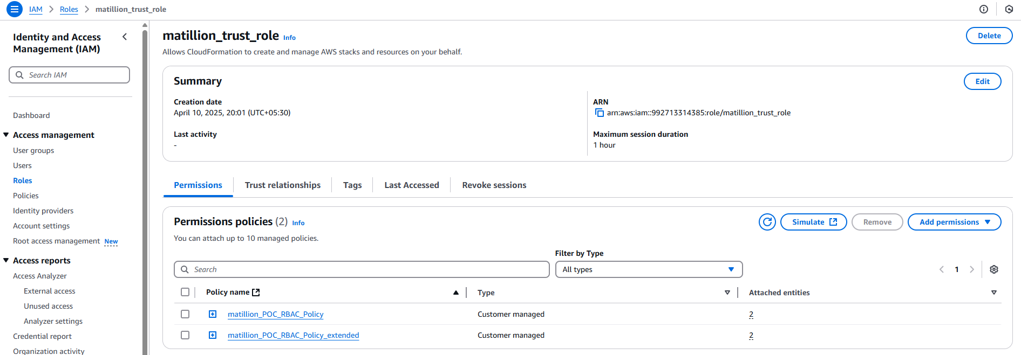

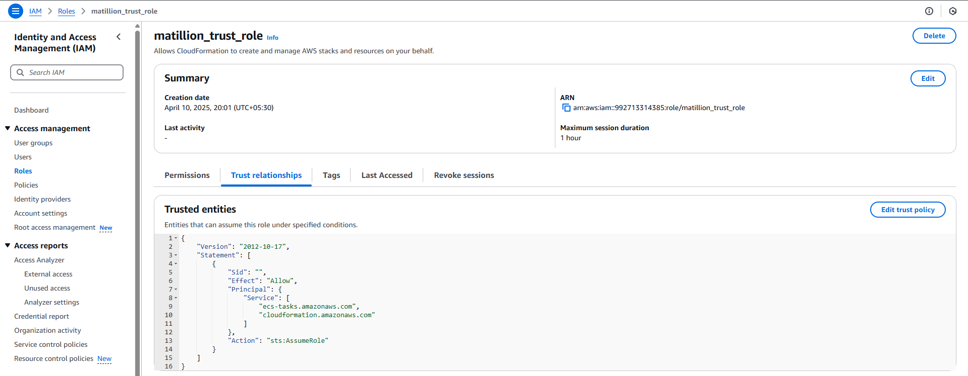
Trusted entities
{
"Version": "2012-10-17",
"Statement": [
{
"Sid": "",
"Effect": "Allow",
"Principal": {
"Service": [
"ecs-tasks.amazonaws.com",
"cloudformation.amazonaws.com"
]
},
"Action": "sts:AssumeRole"
}
]
}

Matillion_role_policy role JSON

{
"Version": "2012-10-17",
"Statement": [
{
"Sid": "AllowIAMRoleActions",
"Effect": "Allow",
"Action": [
"iam:CreateRole",
"iam:PassRole",
"iam:TagRole",
"iam:UntagRole",
"iam:PutRolePolicy",
"iam:AttachRolePolicy",
"iam:CreateInstanceProfile",
"iam:AddRoleToInstanceProfile",
"iam:RemoveRoleFromInstanceProfile",
"iam:DeleteInstanceProfile",
"iam:DeleteRole"
],
"Resource": [
"arn:aws:iam::992713314385:role/matillion_trust_role",
"arn:aws:iam::992713314385:role/*matillion*",
"arn:aws:iam::992713314385:instance-profile/*"
]
},
{
"Sid": "AllowTaggingActions",
"Effect": "Allow",
"Action": [
"tag:TagResources",
"tag:UntagResources"
],
"Resource": [
"*"
]
}
]
}



